**Part A (To be referred by students)**

***Forms, Input Types & Media***

**SAVE THE FILE AND UPLOAD AS (RollNo_Name_Exp1)**

**Topic covered:** Basic Tags of HTML, Forms, Frames & Media

**Learning Objective: Learner would be able to**

1. To present an introduction to Web Programming, with an emphasis on the Web Programming languages like HTML.
2. Describe different architectural components used in web development.

**Aim:**

Create a static-web pages using HTML

1. Interlink the webpages created in expt#1, use attributes link, alink and vlink for text hyperlinks.
2. Make use target attribute for the link (use values: self, blank)
3. Create link to section within same page (of your CV implemented in expt#1)
4. Modify all the tables in Expt#1, use attributes colspan, rowspan, cellspacing, cellpadding and caption tag.
5. Use attribute type for lists in program 1 to change the type of sequence numbering & different symbols for unordered list.
6. Registration page (Now, implement it using form tag)
7. One web page with frames implemented (to display all three web pages implemented in expt #1) column-wise

**Prerequisites:-**

* Basic HTML Tags

**Outcomes:-**

* Students will get idea about how to work with HTML list, table, images.
* Students will be able to work with hyperlinks & its various options.
* Student will be able to work with nested list & table
* Student will be able to design form and frame.

**Theory:-**

**Its good practice to follow following html format:-**

<!DOCTYPE html>  
<html lang="en-us">  
<head>

<meta charset="utf-8">  
  <title> Title</title>  
</head>  
<body>  
  
</body>  
</html>

**Prerequisites:-**

* PPS

**Outcomes:-**

* Student will know about web browser & how it interprets web pages.
* Students will know about how to execute HTML file
* Students will get idea about basic tags of HTML.
* Students will get idea about how to work with HTML list, table and images.

**Anchors <a>**

**Types of link:-**

* Absolute (link to website )
* Relative (link to other files in same system(local file link), link to other section of page)
* Internal
* Graphical
* <a> </a>Tag defines a hyperlink
* Attribute is href…
* By default, links will appear as follows in all browsers:
  + An unvisited link is underlined and blue
  + A visited link is underlined and purple
  + An active link is underlined and red
* The **HTML <body> vlink Attribute**is used to specify a color of a visited link in a Document.
* The **HTML <body> alink Attribute** is used to specify the color of an active link in a document.
* The **HTML <body> link Attribute** is used to specify the default color for a unvisited link in a document.

**Target Attribute: -**

* The target attribute specifies where to open the linked document.
* Syntax:-

<a target="_blank|_self|_parent|_top|*framename*">

* **Attribute values:-**

|  |  |
| --- | --- |
| **Value** | **Description** |
| _blank | Opens the linked document in a new window or tab |
| _self | Opens the linked document in the same frame as it was clicked (this is default) |
| _parent | Opens the linked document in the parent frame |
| _top | Opens the linked document in the full body of the window |
| *framename* | Opens the linked document in the named iframe |

**HTML Form**

* Form is a container where user provides their information, this can be personal information or feedback.
* <form> </form> are used to create interactive GUI
* Form contains following form elements.
* Elements of forms are
  + Text Box.
  + Text Area.
  + Radio Button
  + Check Box
  + Drop Down List
  + Buttons
  + Files
  + Slider etc….
* Forms cannot be nested, but a web page can contain multiple form.
* The actual working of form involves the setting of action and method(GET & POST)attributes.
* Following elements can be used to create an HTML form
  + Form
    - Form elements defines form.& Form element support action attribute.

<form action= “confirm.html”>

* + - Confirm.html File will be opened when user submits the data of the form.
  + Input
    - It enables us to insert
      * Radio button
      * Check boxes
      * Text box
      * password
    - input elements are implemented by <input></input> container tag.
    - Following are the attributes of input
      * Name
      * Type
      * Value
      * MaxLength
      * Size
  + Select & option
    - Used to create a menu or drop down list.
  + Textarea
    - In textarea user can enter large amount of text.
    - Has following attributes
      * Rows
      * Cols
      * name

Note:- Here table tag is used to go give proper look to form

**TextBox & Password**

* Enables us to create text field.
* Values of input element is **“text”** for textbox.
* Values of input element is **“password”** for Password Field.

<form>

<tr>

<td align="right">user name</td>

<td><input type="text" name="usrnm” maxlenghth=15 size=10/></td>

</tr>

<tr>

<td align="right">Password</td>

<td><input type="Password" name="pw" maxlenghth=15 size=10/></td>

</tr>

</form>

**Output**

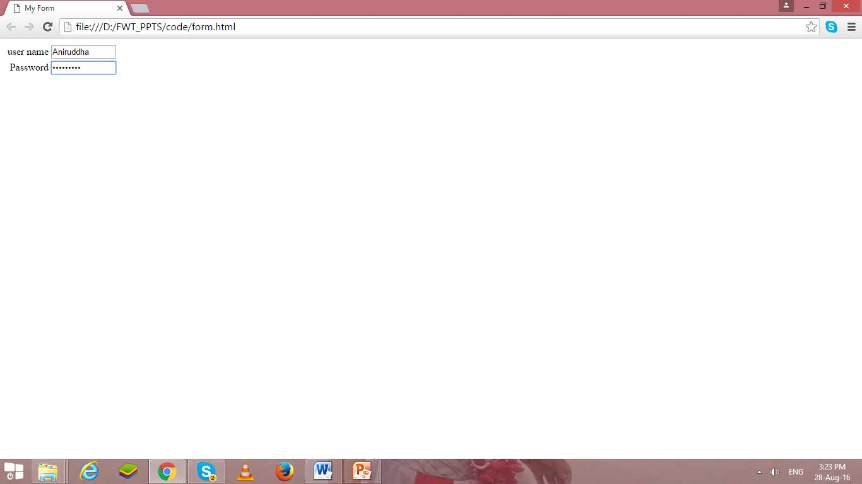

**Text Area**

* Text Area is require for large amount of text.
* Following are commonly used attributes for <textarea>
  + Rows
    - Sets the number of rows of text that visible without scrolling up or down in the fields.
  + Cols
    - Sets the number of rows of text that visible without scrolling left or right in the fields.
  + Name
    - Specifies name of text area.

<form>

<tr>

<td align="right">User Details</td>

<td><textarea rows=5 cols=40></textarea></td>

</tr>

</form>

**OutPut**

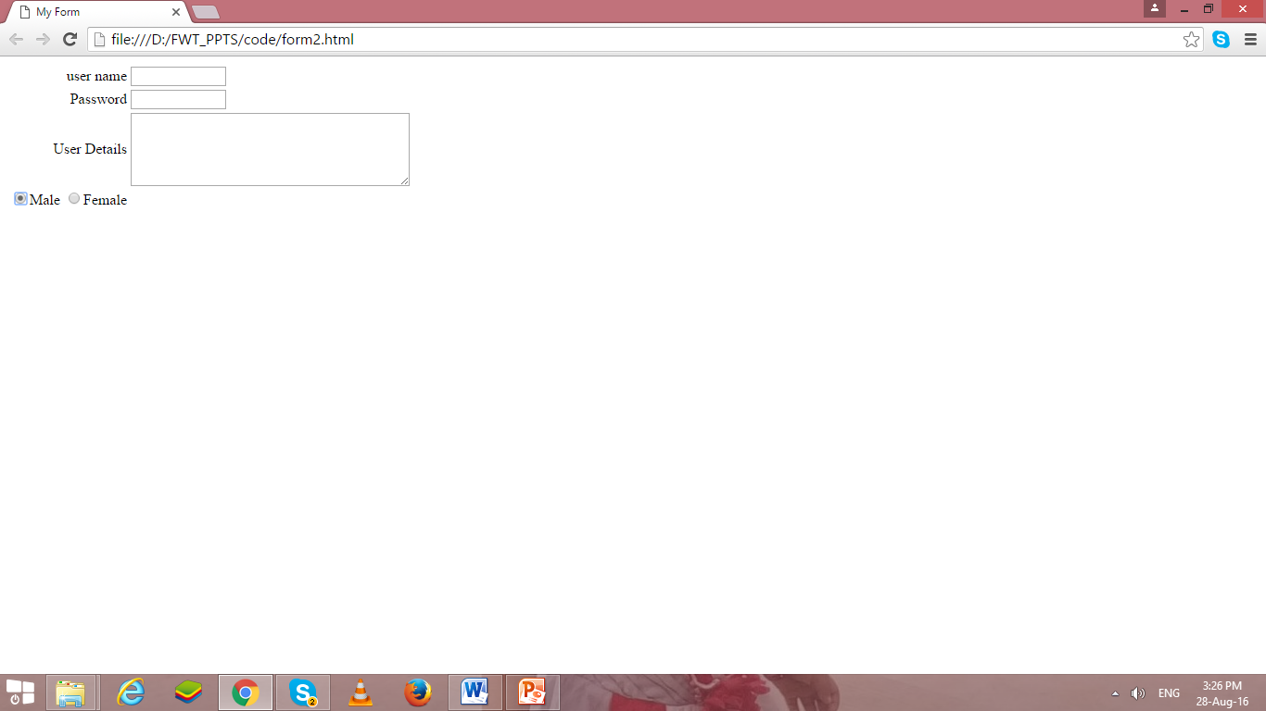

**Radio Button**

* Values of input element is **“radio”** for radio.
* Enables to create radio button.
* We can select only one radio button at a time from group of radio buttons.

<form>

<tr>

<td align="Right"> Gender:

<input type="radio" name="gen" value="m">Male

<input type="radio" name="gen" value="F">Female

</td>

</tr>

</form>

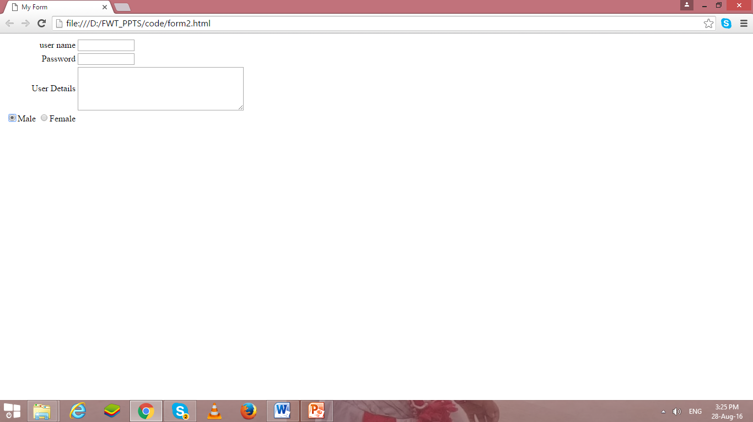

**Check Box**

* Values of input element is **“checkbox”** for enabling checkbox.
* We can select multiple check boxes.

<form>

<tr>

<td align="Right"> Sports Interest:

<input type="checkbox" name="sprt" value="h">Hockey

<input type="checkbox" name="sprt" value="ft">FootBall

</tr>

</form>

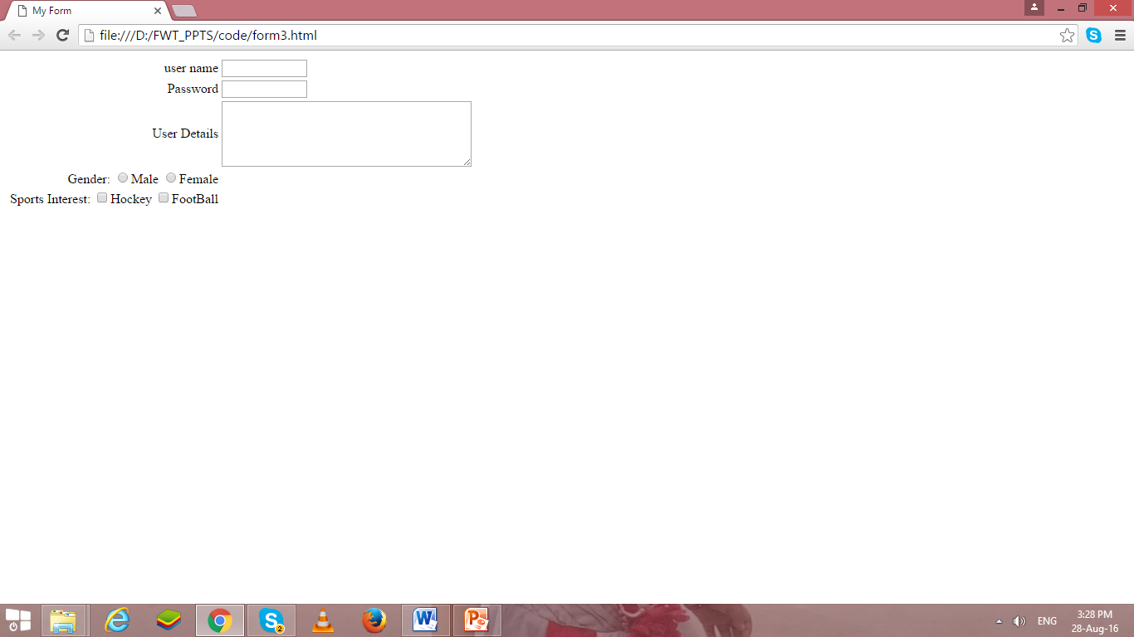

**Drop Down List**

* The select element enables us to create a menu or drop down list in a form, depending on the attribute specified.
* The Select element specifies that the text follows is a list.
* Select element is used with the option element.
* The option element enables us to specify the items of the list created using the select element.
* Functionality of select element is similar to that of unordered list(<ul> </ul>) and ordered list(<ol></ol>) element.
* The option element is similar to list item element (<li>)
* The select element is implemented by using <select> </select> tag
* The option element is implemented by using <option> </option> tag.

<td align="Right"> Branch:</td><td align="left">

<select name="Branch" size=“4”>

<option value="#">--Select--</option>

<option value="ce">Comp Engg</option>

<option value="cs">Comp Science</option>

<option value="cse">Comp Sci & Engg</option>

</select>

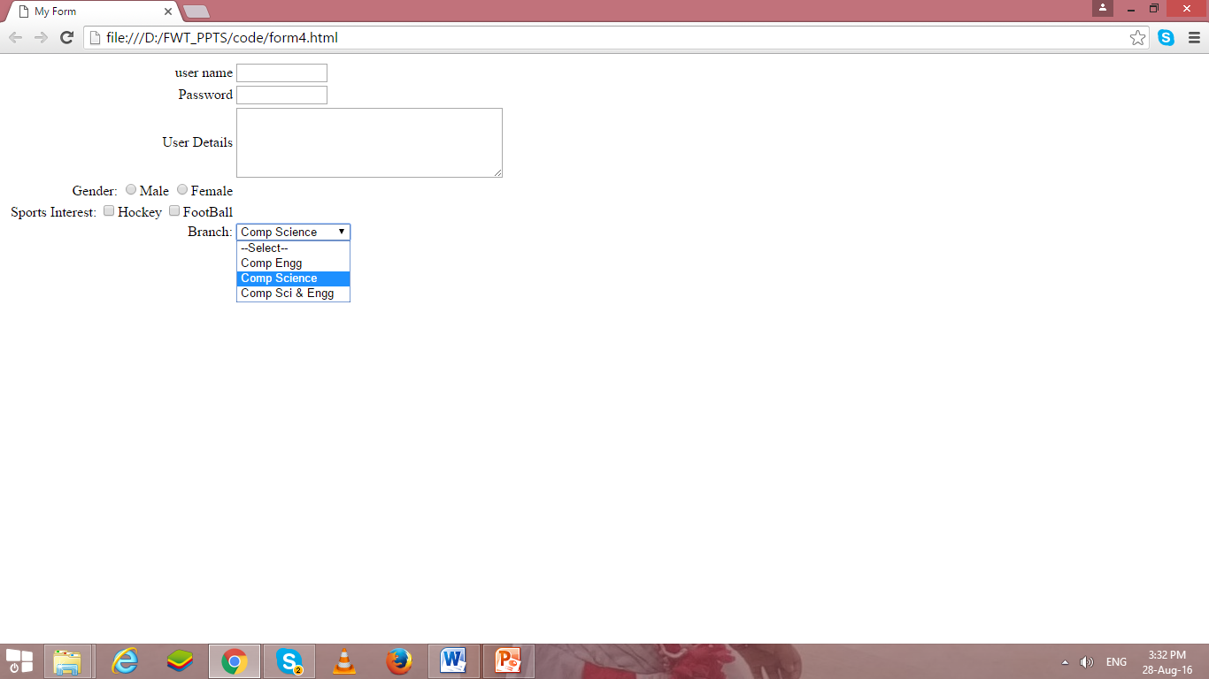

**Button**

* Values of input element is **“submit”** for submit button.
* Values of input element is **“reset”** for reset/clear button.
* Reset and Submit are buttons.
* “Submit” enables to create submit button, when we click submit button, the values of the from are submitted to the web page specified in the action attribute of the form.
* “reset” enables to create reset/clear button , when we click reset button, the values entered in the form are cleared automatically and set back to default values.

</tr>

< tr> <td colspan=2 align="center">

<input type="submit" value="Add to DB"/>

<input type="reset" value="Clear"/>

</tr>

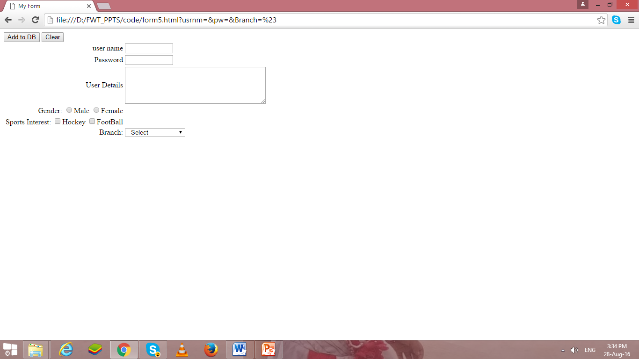

**File**

* Values of input element is **“file”** for uploading file.
* the file are submitted to the path/url specified in the action attribute of the form???

< tr>

<td align=“right"> Select Image to Upload

<input type=“file" value=“upload"/>

</tr>

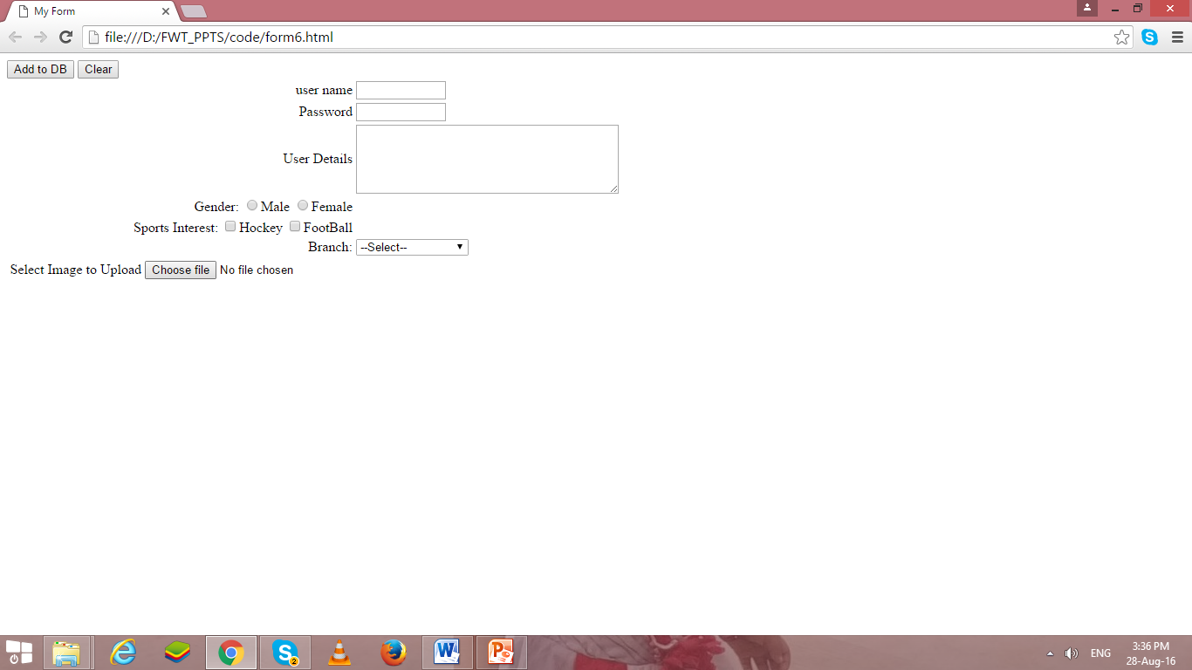

**Image Control**

* Values of input element is **“image”** for graphical submit button.
* If any error occur to open image, then alt values will be displayed.

< tr>

<td align=“right"> Select Image to Upload

<input type=“image" src=“ dj.jpg” alt=“submit”/>

</tr>

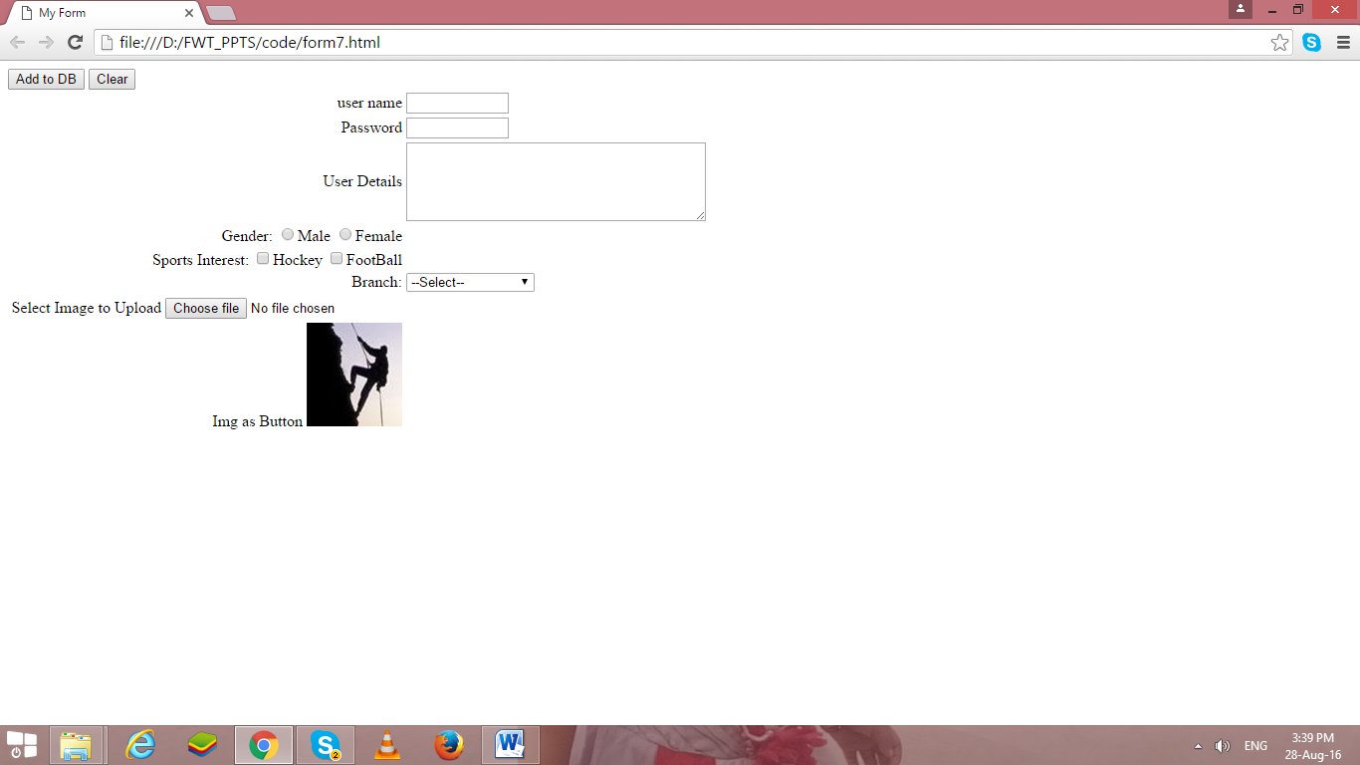

If we integrate above all code, it will generate following form as output.

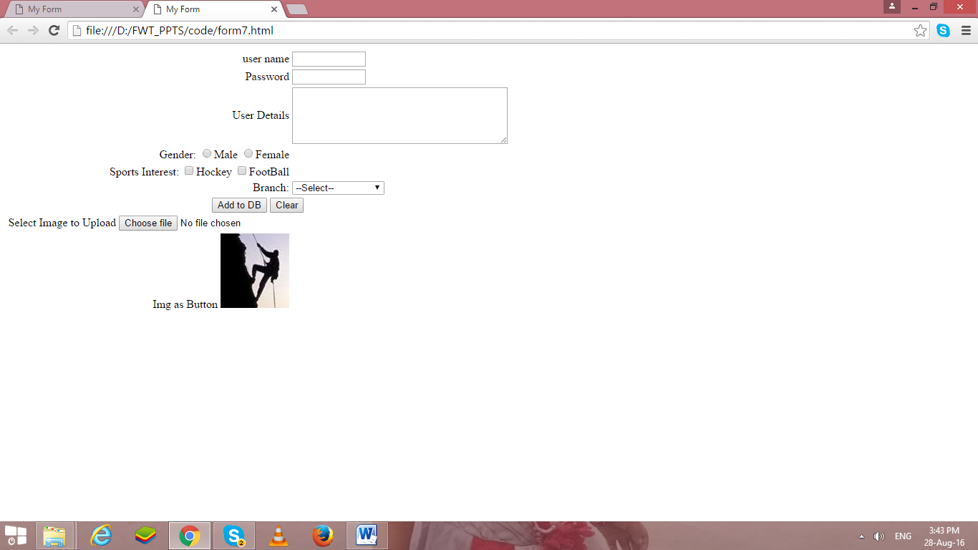

Because the attributes used with input elements varies so much depending on the type of input you want to use, we have provided several specific examples of using different types of input.

**Color:**-

<input type = "color"

value = "#001A57"

id = "clr"

">

* type is color picker
* value is default color value

**Slider/Range:**

<input type = "range"

min = "10"

max = "100"

value = "10"

">

* type is slider
* min is minimum value, max is maximum value
* value is default value
* id lets us refer to input element in JavaScript

***File:-***

<input type = "file"

multiple = "false"

accept = "image/*"

">

* type is file
* multiple = "false" indicates user cannot select multiple files
* accept = "image/*" indicates user can only select image files
* value is default value

**Frames**

* Frame allows us to divide browser window into one or more sub regions.
* Each sub region displaying different HTML documents.
* By using frame in this way, we can view the data of all documents simultaneously.
* Frames are useful when we want to compare data.
* We can also use frame to display an index of link in one sub region and corresponding document in another sub regions
* This way the index never goes out of sight while browsing through the documents.
* Frames divides the browser window horizontally or vertically.
* We can also nest frame with in a another frame.
* We can also display tables, links forms, and images through frame.
* A <frameset> tag is used to create frames in a web page.
* A standard frame has no body element and cannot contain tags normally placed in the body element.
* If they appears in frame, frameset tag ignores.
* With <frameset> tag we can use <frame> and <noframe> tag.
* The frameset tag has two attributes
  + Rows
  + cols
* <frame> tag is used to display different html pages in different frame.
* <frame> has no matching end tag.
* <frame> tag has following attributes
  + Src 🡪url of html file
  + Name 🡪 assign name to frame
  + Marginwidth 🡪can be used when user wants to control margin from frame
  + Marginheight 🡪top and bottom margin
  + Scrolling 🡪whether frame should have scroll bar or not..
  + Noresize 🡪has no value & which means that frame cannot be resized by user.
  + Frameboarder 🡪control the display of frame border.
  + Framespacing 🡪 to set extra space around the frame.
* Use the *name* attribute to name a frame, then target the frame name with hyperlinks
* The syntax for naming a frame is as follows:

<frame src="*url*" name="*framename*"/>

* Load a web page into a frame using **src** attribute

**Example:-**

<html>

<head >

<title> Image</title>

</head>

<frameset cols="25%,*,25%">

<frame src="base.html">

<frame src="form7.html">

<frame src="img.html">

</frameset>

</html>

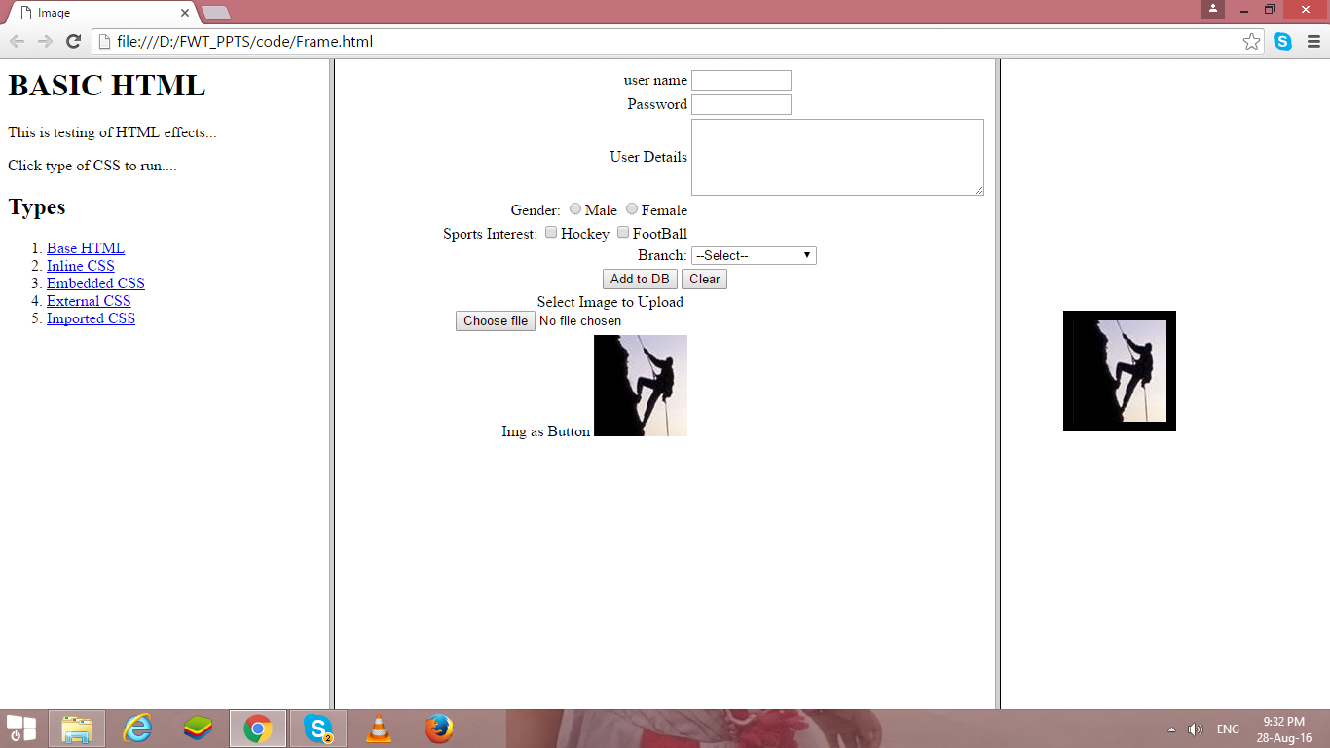

**Ex1:**

<frameset rows="40%,60%">  
<frame src="top.htm" name="top">  
<frame src="bottom.htm" name="bottom">  
</frameset>

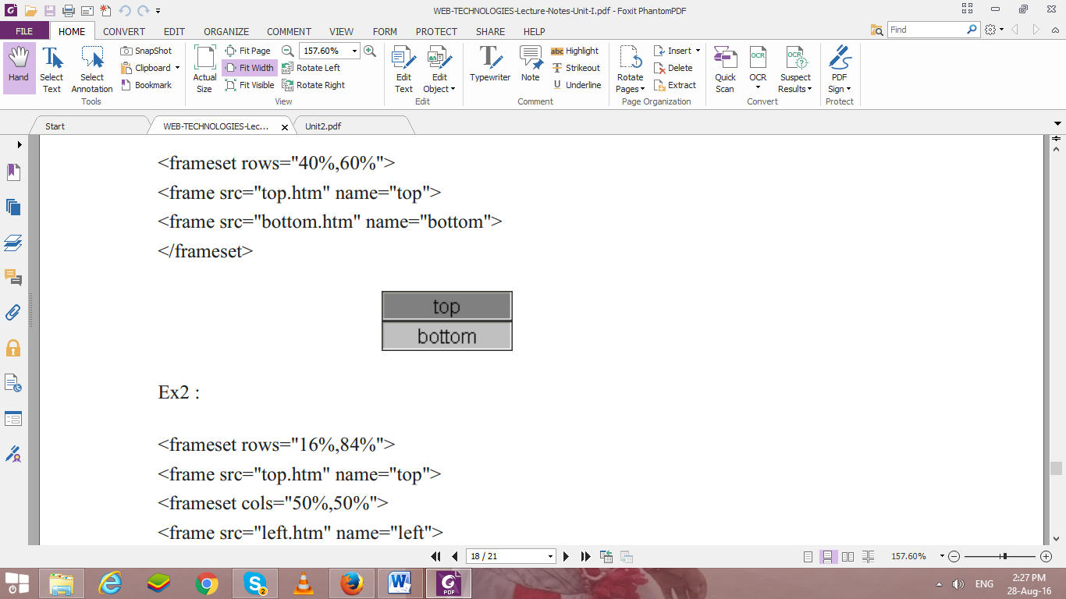  
**Ex2 :**  
<frameset rows="16%,84%">  
<frame src="top.htm" name="top">  
<frameset cols="50%,50%">  
<frame src="left.htm" name="left">  
<frame src="right.htm" name="right">  
</frameset></frameset>

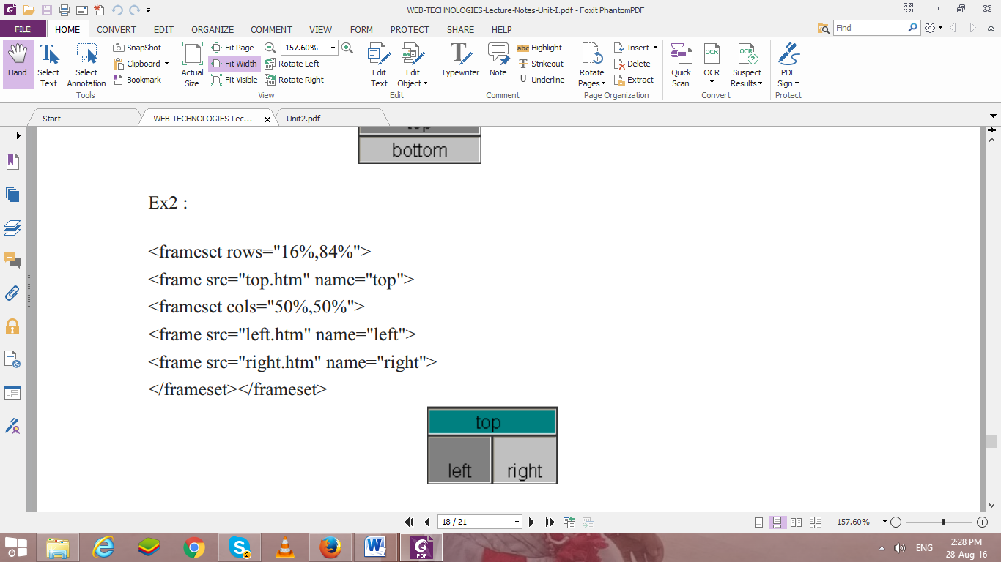

**Instructions:-**

1. Write html code in Note Pad & save with .html extension.
2. Do display your roll number in title of every page.
3. Execute using Web Browser.
4. Copy and Paste code as well as output (Print Scrn of output) in Part B

**PART B**

(Students must submit the soft copy as per the following segments. A soft copy containing Part A and Part B must be uploaded on the platform specified by the Practical Teacher. The filename should be **RollNo_Name_Exp1**)

|  |  |
| --- | --- |
| **Roll No.:**K041 | **Name:** Anish Sudhan Nair |
| **Prog/Yr/Sem:** B.Tech. Cybersecurity | **Batch:** K2/A2 |
| **Date of Experiment:** 17/12/2021 | **Date of Submission:** 24/12/2021 |

**Aim: - Design following –webpages using HTML Forms**

Create a static web pages using HTML

1. Create one HTML to interlink the webpages created in expt#1, use attributes link, alink and vlink for text hyperlinks.
2. Make use target attribute for the link (use values: self, blank)
3. Create link to section within same page (of your CV implemented in expt#1)
4. Modify all the tables in Expt#1, use attributes colspan, rowspan, cellspacing, cellpadding and caption tag.
5. Use attribute type for lists in program 1 to change the type of sequence numbering & different symbols for unordered list.
6. Registration page (Now, implement it using form tag)
7. One web page with frames implemented (to display all three web pages implemented in expt #1) column-wise
8. **Create Web Page using following tags with your creativity…**

* Use media tags <audio>,<video>
* The forms created in previous practical’s need to updated with more HTML 5 tags and attributes (Use

<input> tags type attribute as radio, checkbox, number, range, datetime-local,

**Note:- Don’t use any type of CSS in your code…**

**HTML Code 1 and 2 : -**

**<!DOCTYPE HTML5>**

**<html lang="en-us">**

**<head>**

**<meta charset="utf-8">**

**<title>Assignment 2.1, 2.2 - AnishSudhanNair</title>**

**</head>**

**<body vlink="red" alink="green" link="blue">**

**<h1>Links to Assignment 1 pages</h1>**

**<a href="../Lab1/Assignment1_contact.html" target="self">Contact Page</a>**

**<a href="../Lab1/Assignment1_reg.html" target="blank">Registration Page</a>**

**<a href="../Lab1/Assignment1AnishCV.html" target="self">Anish's CV</a>**

**</body>**

**</html>**

**Output (only in print screen format) Code -1 & 2**

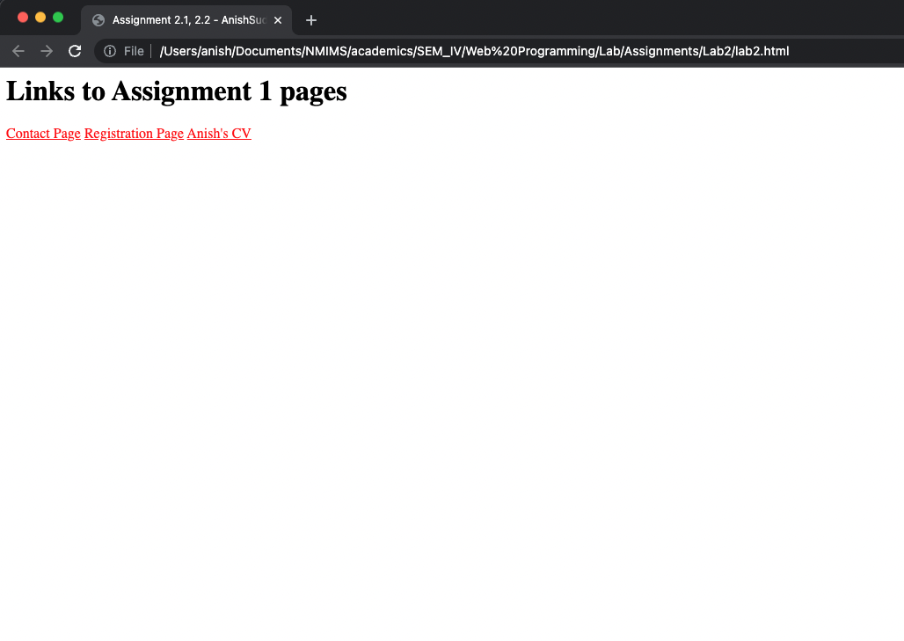

**HTML Code 3 ,4 and 5 : -**

**<!DOCTYPE html5>**

**<html>**

**<head>**

**<title>Assignment 2.3-5 - Anish Sudhan Nair</title>**

**<style>**

**\**

**h3 {**

**color: gray**

**}**

**table,**

**tr,**

**th,**

**td {**

**border: 1px solid black;**

**padding: 3px;**

**border-spacing: 2px**

**}**

**</style>**

**<a href="#OBJECTIVE">Objective</a>**

**<br>**

**<a href="#EDUCATION">Education</a>**

**<br>**

**<a href="#TECHNICAL SKILLS">Techincal Skills</a>**

**<br>**

**<a href="#KEY PROJECTS">Key Projects</a>**

**<br>**

**<a href="#PRESENTATION">Technical Presentations</a>**

**<br>**

**<a href="#WORK">Technical Workshops and Internships</a>**

**</head>**

**<body style="padding:30px">**

**<center>**

**<img src="https://upload.wikimedia.org/wikipedia/en/e/ec/Narsee_Monjee_Institute_of_Management_Studies_Logo.png" width="100 px" height="100px">**

**</center>**

**<h2><b>B.TECH. COMPUTER ENGINEERING</b></h2>**

**<h2><b>Name:- Anish Sudhan Nair</b></h2>**

**<h2 style="underline" id="OBJECTIVE"><u>OBJECTIVE:</u></h2>**

**Well, get a job, maybe.**

**<h2 style="underline" id="EDUCATION"><u>EDUCATION:</u></h2>**

**<table border="1">**

**<caption>Education Details</caption>**

**<tr>**

**<th>Degree</th>**

**<th>Institute</th>**

**<th>Board/University</th>**

**<th>CGPA/Percentage</th>**

**<th>Year</th>**

**</tr>**

**<tr>**

**<td>B.Tech Computer Science and Engineering (Cybersecurity)</td>**

**<td>MPSTME</td>**

**<td>NMIMS</td>**

**<td>3.89</td>**

**<td>Currently Pursuing</td>**

**</tr>**

**<tr>**

**<!-- <td>XII</td>**

**<td>Lilavatibai Podar Senior Secondary School</td>**

**<td>ISC</td>**

**<td>96.75%</td>**

**<td>2020</td> -->**

**<td>XII</td>**

**<td rowspan="2">Lilavatibai Podar Senior Secondary School</td>**

**<td>ISC</td>**

**<td>96.75%</td>**

**<td>2020</td>**

**</tr>**

**<tr>**

**<td>X</td>**

**<!-- <td>City International School</td> -->**

**<td>ICSE</td>**

**<td>96.8%</td>**

**<td>2018</td>**

**</tr>**

**</table>**

**<h2 style="underline" id="TECHNICAL SKILLS"><u>TECHNICAL SKILLS:</u></h2>**

**<table>**

**<tr>**

**<th>Domain</th>**

**<th>Details</th>**

**</tr>**

**<tr>**

**<th>Languages</th>**

**<td>Java, Python 3, SQL, Dart(Flutter), C</td>**

**</tr>**

**<tr>**

**<th>Web Designing</th>**

**<td>HTML5, CSS6, Wix</td>**

**</tr>**

**<tr>**

**<th>Software</th>**

**<td>VMWare Workstation Player, Burpsuite, Wireshark, Figma, Blender, MS Office 2016 (Word, Excel, Powerpoint)</td>**

**</tr>**

**<tr>**

**<th>Database</th>**

**<td>Firebase, MySQL, SQLite 3, Datastax Astra</td>**

**</tr>**

**<tr>**

**<th>Analytics</th>**

**<td>-</td>**

**</tr>**

**<tr>**

**<th>Operating Systems</th>**

**<td>Windows (7,8,11), Linux (Ubuntu, Kali)</td>**

**</tr>**

**</table>**

**<h2 style="underline" id="KEY PROJECTS"><u>KEY PROJECTS:</u></h2>**

**<table>**

**<tr>**

**<th>Project Title</th>**

**<th>Duration</th>**

**<th>Platform Used</th>**

**<th>Brief Description</th>**

**<th>Year</th>**

**</tr>**

**<tr>**

**<td>Android Encryption App</td>**

**<td>1 week</td>**

**<td>Android Studio, Firebase</td>**

**<td>An android app that encrypts plain text provided by the user using a key they provide for ceaser cipher</td>**

**<td>2021</td>**

**</tr>**

**<tr>**

**<td>Delego</td>**

**<td>1.5 years</td>**

**<td>Android Studio, Firebase, Github</td>**

**<td>A multi-platform app to be used during MUN conferences to facilitate conduction of the same</td>**

**<td>2020-21</td>**

**</tr>**

**</table>**

**<h2 style="underline" id="PRESENTATION"><u>TECHNICAL-PRESENTATION/WORKSHOPS/CERTIFICATION</u></h2>**

**<ul type="square">**

**<li>IET Python for Data Science Workshop, 2020</li>**

**<li>ISME Management Bootcamp, 2019</li>**

**</ul>**

**<h2 style="underline" id="WORK"><u>TECHNICAL-WORK EXPERIENCE/INTERNSHIPS</u></h2>**

**<ol type="I">**

**<li>Finbits India</li>**

**<li>INE</li>**

**</ol>**

**</body>**

**</html>**

**Output (only in print screen format) Code -3 to 5**

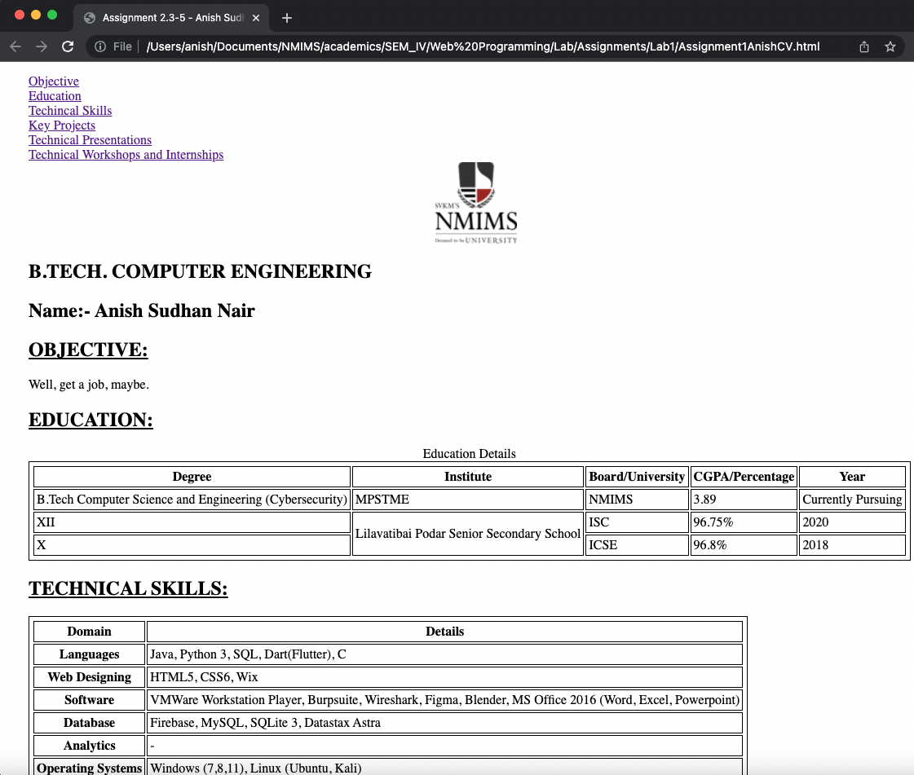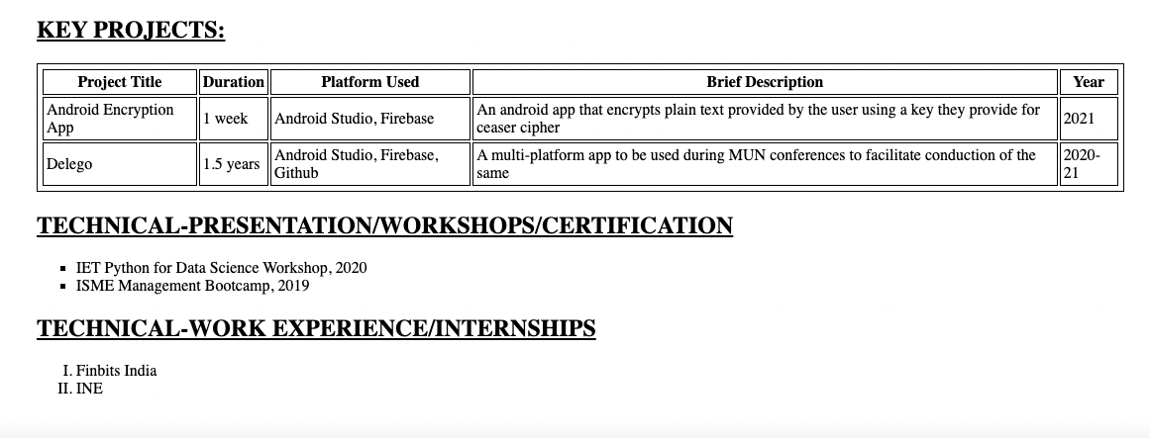

**HTML Code 6 : -**

**<!DOCTYPE html>**

**<html lang="en" dir="ltr">**

**<head>**

**<meta charset="utf-8">**

**<title>Assignment 2.6 - AnishSudhanNair</title>**

**</head>**

**<body>**

**<center>**

**<h1 style="margin-top: 30px">Registration Page</h1>**

**</center>**

**<form action="form_result.html">**

**<fieldset>**

**<legend>User Information</legend>**

**<label for="username">User Name: </label> <br>**

**<input type="text" id="username" name="username">**

**<br>**

**<label for="firstname">First Name: </label> <br>**

**<input type="text" id="firstname" name="firstname">**

**<br>**

**<label for="lastname">Last Name: </label> <br>**

**<input type="text" id="lastname" name="lastname">**

**<br>**

**<br>**

**<label for="gender">Gender: </label> <br>**

**<input type="radio" id="gender" name="gender" value="male">Male**

**<input type="radio" id="gender" name="gender" value="female">Female**

**<input type="radio" id="gender" name="gender" value="others">Others**

**<br>**

**<br>**

**<label for="status">Marriage Status: </label> <br>**

**<select name="status" id="status">**

**<option value="married">Married</option>**

**<option value="unmarried">Unmarried</option>**

**<option value="divorced">Divorced</option>**

**</select>**

**<br>**

**<br>**

**<label for="address">Address: </label> <br>**

**<textarea name="address" rows="5" cols="20"></textarea>**

**<br>**

**<br>**

**<label for="mobile">Mobile No.: </label> <br>**

**<input type="text" id="mobile" name="mobile">**

**<br>**

**<label for="email">Email Id: </label> <br>**

**<input type="email" id="email" name="email">**

**<br>**

**<label for="password">Password: </label> <br>**

**<input type="password" id="password" name="password" minlength="8">**

**<br>**

**<label for="confirm_password">Confirm Password: </label> <br>**

**<input type="password" id="confirm_password" name="confirm_password" minlength="8">**

**<br>**

**<br>**

**<label for="image">Profile Picture: </label>**

**<input type="file" name="image" id="image" accept="image/*">**

**<br>**

**<br>**

**<label for="notifs">Email notifications: </label> <br>**

**<input type="checkbox" id="news" name="news" value="Newsletter">**

**<label for="news">Newsletter</label> <br>**

**<input type="checkbox" id="promo" name="promo" value="Promotions">**

**<label for="promo">Promotions</label> <br>**

**<br>**

**<!-- Submit button -->**

**<input type="submit" name="submit" value="Submit">**

**<input type="reset" name="reset" value="Reset">**

**</fieldset>**

**</form>**

**</body>**

**</html>**

**Output (only in print screen format) Code -6**

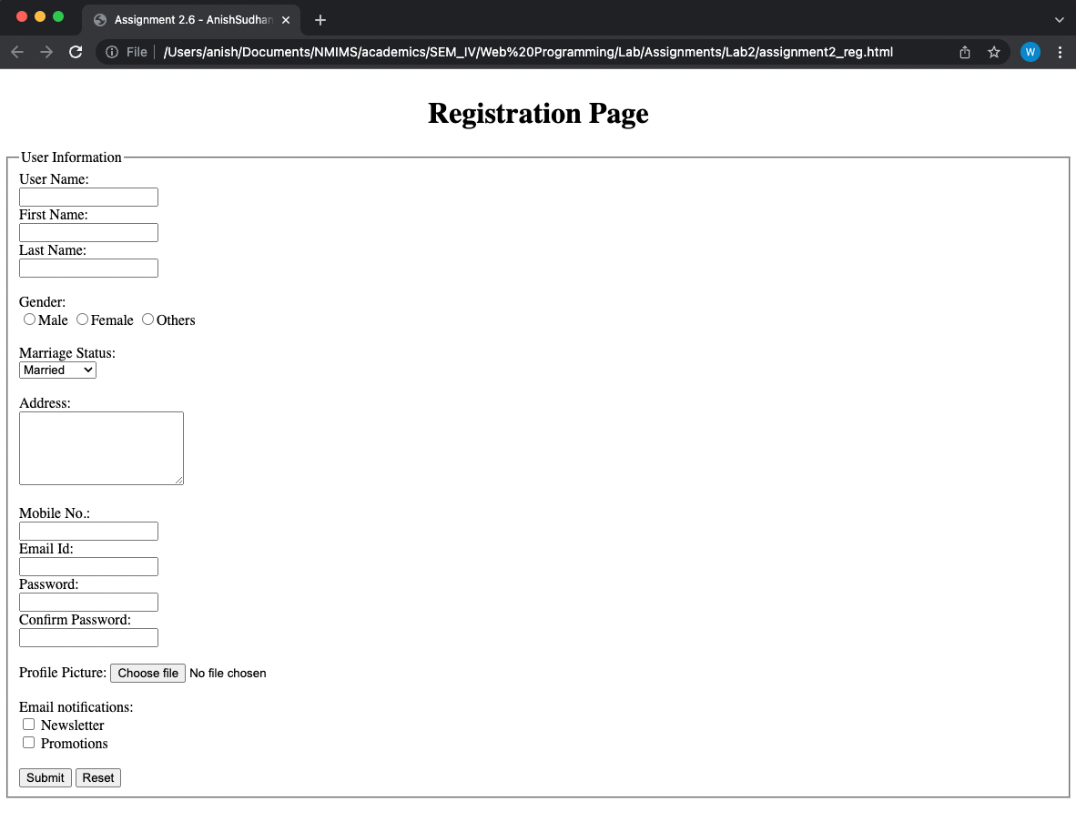

**HTML Code 7 : -**

**<!DOCTYPE HTML5>**

**<html lang="en" dir="ltr">**

**<head>**

**<meta charset="utf-8">**

**<title>Assignment 2.7 - AnishSudhanNair</title>**

**</head>**

**<frameset cols="25%,50%,25%">**

**<frame name="left" src="Assignment2_reg.html"/>**

**<frame name="center" src="../Lab1/Assignment1AnishCV.html"/>**

**<frame name="right" src="../Lab1/Assignment1_contact.html"/>**

**</frameset>**

**<body>**

**</body>**

**</html>**

**Output (only in print screen format) Code -7**

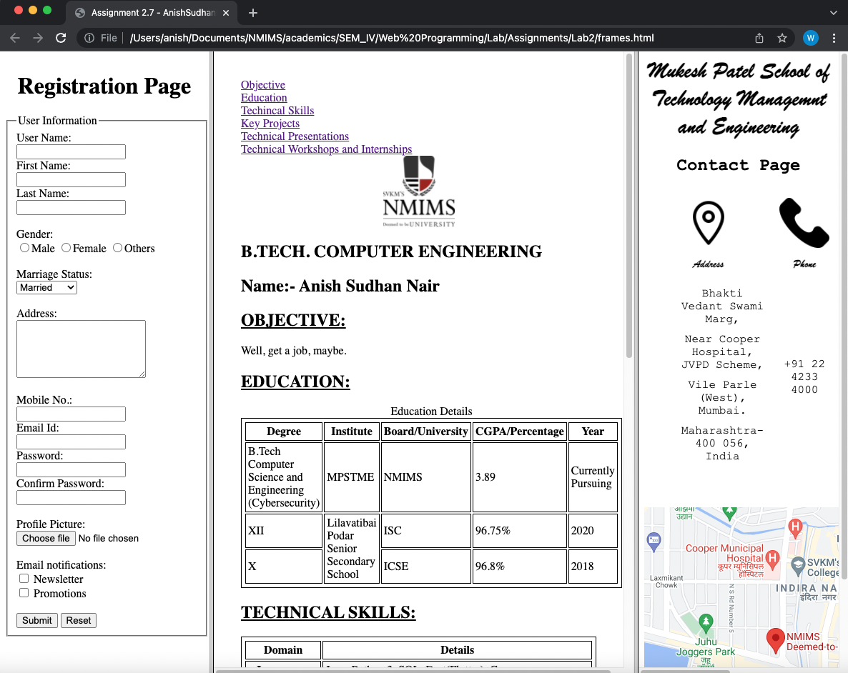

**HTML Code 8 : -**

**creativity.html**

**<!DOCTYPE HTML5>**

**<html lang="en" dir="ltr">**

**<head>**

**<meta charset="utf-8">**

**<title>Lab2_Part8_AnishSudhanNair</title>**

**<style media="screen">**

**h1{**

**margin: 0px;**

**font-size: 70px;**

**padding-left:20px;**

**}**

**#logo{**

**padding-left: 50px;**

**}**

**h2{**

**font-size: 30px;**

**padding-bottom: 30px**

**}**

**img{**

**padding-bottom: 1px;**

**margin-bottom: 0px;**

**}**

**</style>**

**</head>**

**<body alink="black" vlink="black" link="black">**

**<h1>Brivago.</h1>**

**<i id="logo" >Holidays made simple</i>**

**<br>**

**<center>**

**<video src="holidays.mp4" autoplay poster="posterimage.jpg" width="1080" height="720" loop>**

**Video Not displaying**

**</video>**

**<audio src="holidays.mp3" autoplay type="audio/mp3">**

**</audio>**

**<a href="check-in.html">**

**<!-- <img src="next.png" alt="" height="30"> -->**

**<h2>Dive In.</h2>**

**</a>**

**</center>**

**</body>**

**</html>**

**check-in.html**

**<!DOCTYPE HTML5>**

**<html lang="en" dir="ltr">**

**<head>**

**<meta charset="utf-8">**

**<title>Assignment 2.8 - AnishSudhanNair</title>**

**<style media="screen">**

**lable, input, select{**

**margin-bottom:7px;**

**}**

**</style>**

**</head>**

**<body>**

**<center style="padding:5px">**

**<h1>Search for Resorts!</h1>**

**</center>**

**<form action="form_result.html">**

**<fieldset>**

**<!-- <legend>Booking Information</legend> -->**

**<h2>Resort Booking Information</h2>**

**<label for="location">Location </label> <br>**

**<select name="location" id="location">**

**<option value="Goa">Goa</option>**

**<option value="Mussoorie">Mussoorie</option>**

**<option value="Alappuzha">Alappuzha</option>**

**</select>**

**<br>**

**<label for="occupants_adult">No. of Adults </label> <br>**

**<input type="text" id="occupants_adult" name="occupants_adult">**

**<br>**

**<label for="occupants_child">No. of Children </label> <br>**

**<input type="text" id="occupants_child" name="occupants_child">**

**<br>**

**<label for="check_in">Check-in </label> <br>**

**<input type="date" id="check_in" name="check_in">**

**<br>**

**<label for="check_out">Check-out </label> <br>**

**<input type="date" id="check_out" name="check_out">**

**<br>**

**<label for="price">Pricing </label> <br>**

**2000 <input type="range" name="price" value="10000" min="2000" max="50000"> 50000**

**</fieldset>**

**<br>**

**<fieldset>**

**<h2>Customer Booking Information</h2>**

**<label for="firstname">First Name: </label> <br>**

**<input type="text" id="firstname" name="firstname">**

**<br>**

**<label for="lastname">Last Name: </label> <br>**

**<input type="text" id="lastname" name="lastname">**

**<br>**

**<br>**

**<label for="gender">Gender: </label> <br>**

**<input type="radio" id="gender" name="gender" value="male">Male**

**<input type="radio" id="gender" name="gender" value="female">Female**

**<input type="radio" id="gender" name="gender" value="others">Others**

**<br>**

**<br>**

**<label for="status">Marriage Status: </label> <br>**

**<select name="status" id="status">**

**<option value="married">Married</option>**

**<option value="unmarried">Unmarried</option>**

**<option value="divorced">Divorced</option>**

**</select>**

**<br>**

**<br>**

**<label for="address">Residence </label> <br>**

**<textarea name="address" rows="5" cols="20"></textarea>**

**<br>**

**<br>**

**<label for="mobile">Mobile No. </label> <br>**

**<input type="tel" id="mobile" name="mobile">**

**<br>**

**<label for="email">Email Id </label> <br>**

**<input type="email" id="email" name="email">**

**<br>**

**<label for="password">Password </label> <br>**

**<input type="password" id="password" name="password" minlength="8">**

**<br>**

**<label for="confirm_password">Confirm Password </label> <br>**

**<input type="password" id="confirm_password" name="confirm_password" minlength="8">**

**<br>**

**<br>**

**<label for="image">Profile Picture </label>**

**<input type="file" name="image" id="image" accept="image/*">**

**<br>**

**</fieldset>**

**<br>**

**<fieldset>**

**<h2>Enquiry Submission</h2>**

**<label for="notifs">Email notifications </label> <br>**

**<input type="checkbox" id="news" name="news" value="Newsletter">**

**<label for="news">Newsletter</label> <br>**

**<input type="checkbox" id="promo" name="promo" value="Promotions">**

**<label for="promo">Promotions</label> <br>**

**<br>**

**<!-- Submit button -->**

**<input type="submit" name="submit" value="Submit">**

**<input type="reset" name="reset" value="Reset">**

**</fieldset>**

**</form>**

**</body>**

**</html>**

**Output (only in print screen format) Code -7**

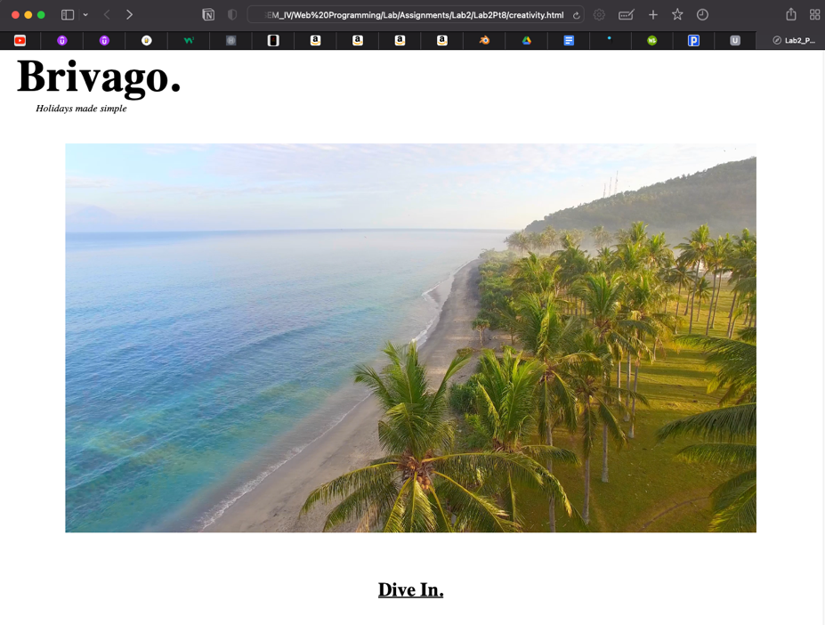

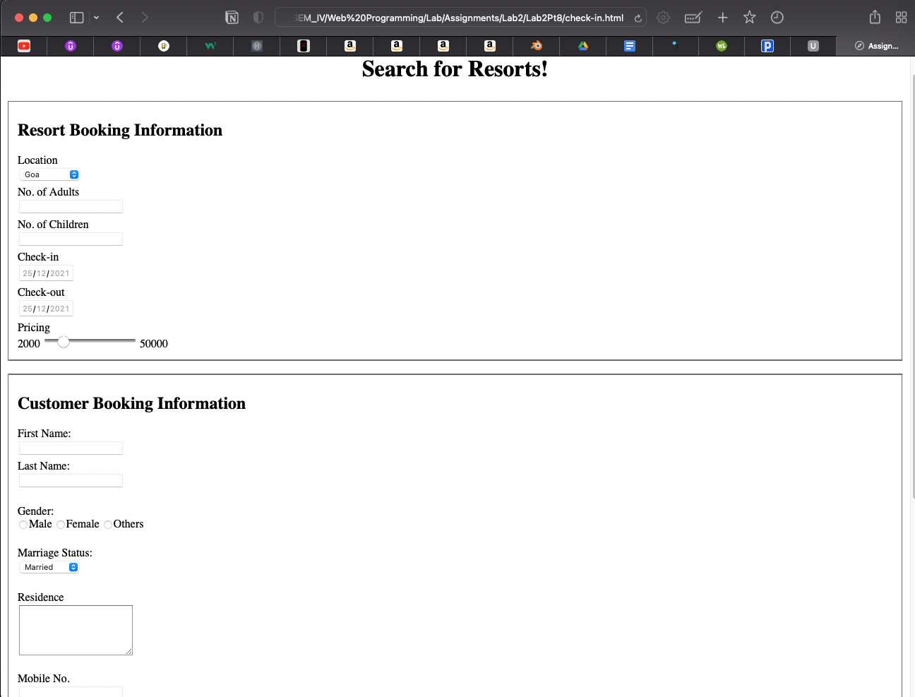

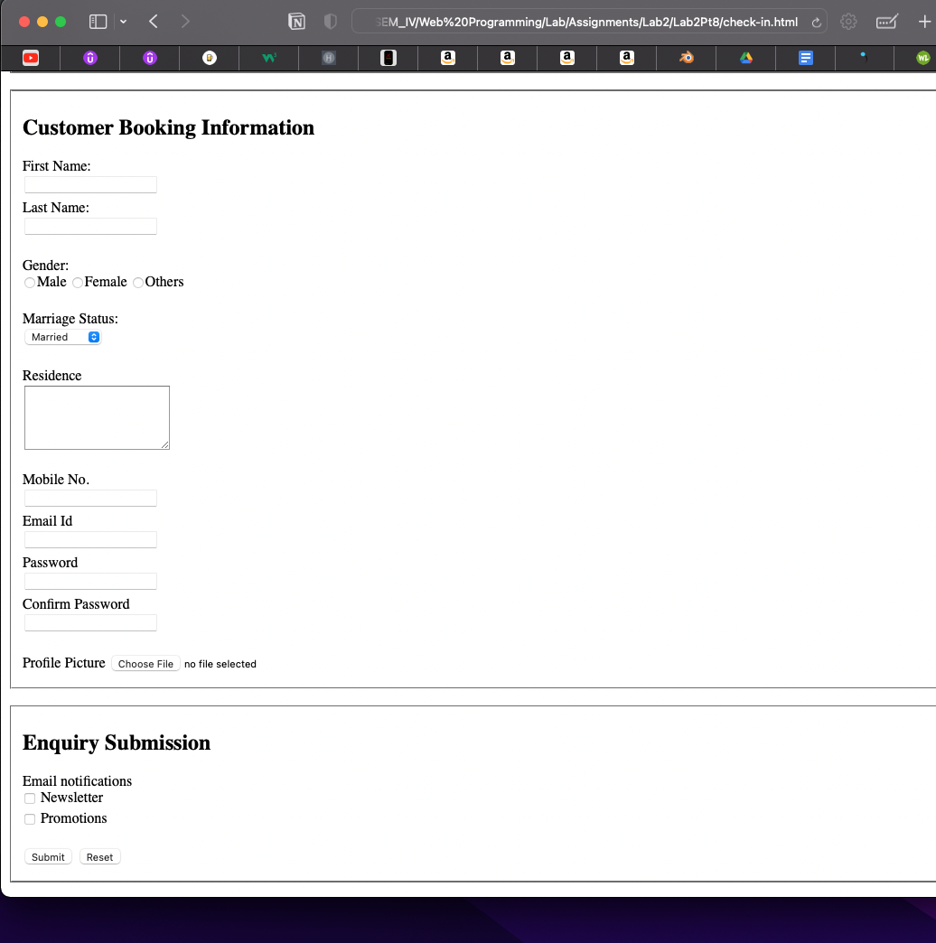

**Observation and Learning: -**

**Introduction to fundamental html tags – enables creation of basic web page structure, defining the areas and what needs to go where.**

**Forms can be easily created with the aid of form tag and its supplementary tags, alongside their attributes.**

**Designing capabilities are severely handicapped in the absence of CSS.**

**Answer the Questions: -**

1. What is hyperlink in HTML? Which tag is used? What are various attributes of <a>? explain.

* A hyperlink is simply a click that a user can follow to get to another piece of data. In html, using anchor tags, we can embed links, clicking on which would lead to another web page.
* <a> tag is used
* Attributes include href which indicates the link’s destination, target indicates how the destination page must be shown to the user and type indicates the type of linked document.

1. What are various list tags?

* HTML primarily has two kinds of lists – ordered and unordered. Ordered lists are implemented with the <ol> and follow a logical natural sequence while unordered lists are implemented with the <ul> tag wherein there is no sequencing.

1. What are various table tags?

* A table in html is defined using <table> tag which consist of several other tags that make up a table’s elements.
* <tr> is used to define a row of the table
* <th> is used to define a column header by giving it special formatting
* <td> is used to define a cell within the table
* Additional tags include <tbody>, <thead>, <tfoot> and <caption>

1. List out various form elements and their associated tags.

* In html, a form is defined using the <form> element, to enable user input.
* The <input> element is used for taking user’s input in various formats and types including email, telephone, password, radio, checkbox etc
* <label> is used for providing a label or name to an input element
* <select> is used for enabling drop down menu items
* <textarea> is used for defining a multi-line input
* <button> is used to create a clickable button

**Conclusion:**

**This practical experiment introduced us to more html tags, a refined manner of creating forms and other elements useful for defining a web page’s structure. Additionally, by building upon previous assignments and creating web pages from scratch we were able to reinforce our learning and knowledge of html.**